**SOUTHERN RIVER COLLEGE**

**Human Biological Science**

**Unit 3 & 4**

**TASK 11 – Test 5**

**Hominid Evolutionary Trends**

**Time: 60 mins**

Multiple Choice: 12 marks

Short Answer: 34 marks

Extended Answer: 12 marks

TOTAL 58 MARKS

**Weighting: 5%**

**Do not write on this question booklet**

**Do not turn page until instructed to do so**

**Section A: Multiple Choice (12 Marks)**

Answer all questions by placing an X through the most correct answer on the multiple choice answer sheet.

Questions 1 & 2 refer to the lower jaw diagrams shown below.



Jaw R

Jaw Q

Jaw P

1. Which of the following statements about the lower jaws shown in the diagrams is correct?
2. Jaw P belongs to a modern human because the dental arcade has a parabolic shape.
3. Jaw Q belongs to an ape because the teeth are of an even size.
4. Jaw P belongs to an ape because of the presence of a diastema.
5. Jaw Q belongs to a modern human because there are more molars present than in Jaw P.
6. If the complete skeleton of the specimen belonging to Jaw R was examined, which of the following characteristics would it be expected to have?
7. Longitudinal and transverse arches of the foot
8. Small outer condyle of the femur at the knee joint
9. Only one curvature of the vertebral column
10. Bowl shaped pelvis that is long from top to bottom
11. Which of the following correctly matches the hominid to the associated lifestyle change?
12. Homo habilis – food sharing, Homo erectus – cave murals
13. Homo habilis – use of fire, Homo sapiens – cooperative hunting
14. Homo neanderthalensis – development of agriculture, Australopithecines – home bases
15. Homo habilis – food sharing, Homo erectus – cooperative hunting
16. Compared to Homo erectus, the Neanderthals had a:
17. prominent brow ridge.
18. prognathic face.
19. larger brain size.
20. shorter sagittal crest.
21. With which of the hominids is the use and control of fire associated?
22. Homo sapiens
23. Homo habilis
24. Homo neanderthalensis
25. Homo erectus
26. A fossilised skeleton was discovered in a semi-arboreal region of Africa. Paleoanthropologists determined that the skeleton is bipedal due to several distinguishing features. What features would you expect to be present in this skeleton?

1. Narrow pelvis, s-shaped spine, protruding jaw
2. Central foramen magnum, protruding jaw, short pelvis
3. S-shaped spine, long pelvis, central foramen magnum
4. Broad pelvis, central foramen magnum, s-shaped spine

1. The following list refers to hominid physical characteristics:
2. Small brain size relative to body size.
3. Dental diastema.
4. Centrally placed foramen magnum.
5. S-Shaped vertebrae curve.
6. Transverse arch in the foot.
7. Prominent brow ridges

Which characteristics would you expect to find in a fossilised pongid (ape)?

1. 1, 2 and 6
2. 1, 5 and 6
3. 2, 4 and 6
4. 1, 4 and 6

Questions 8 and 9 refer to the diagram below of hominid lower limbs.

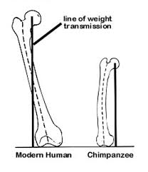

**A B**

1. The femur of hominid A has a greater carrying angle than hominid B. This is because hominid A is
   1. human and the carrying angle allows it to have a wider pelvis than an ape, to assist in childbirth.
   2. an ape and the carrying angle increases the length of the femur to allow for quadrupedal walking.
   3. an ape and the carrying angle allows the knee to bend and straighten for bipedal walking.
   4. human and the carrying angle places the foot under the centre of gravity for a striding gait.
2. The foot of hominid A would have
   1. a larger calcaneus (heel bone) than hominid B.
   2. a longitudinal arch that is lacking in hominid B.
   3. greater opposability of the big toe than hominid B.
   4. a more flexible ankle joint than hominid B.

Questions 10 and 11 refers to the diagram below.

COMMON PYGMY

GIBBON ORANGUTAN GORILLA CHIMP CHIMP HUMAN

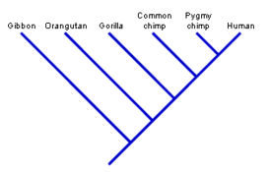

1. Using the data in the phylogenetic tree pictured above, which two (2) organisms are the most closely related?
2. Pygmy chimp and human
3. Common chimp and human
4. Orangutan and common chimp
5. Human and gibbon
6. Which two (2) organisms are the most distantly related?
7. Pygmy chimp and human
8. Common chimp and human
9. Orangutan and common chimp
10. Pigmy chimp and gibbon
11. Humans have opposable thumbs. Opposable thumbs allow humans to:
12. grasp objects.
13. write with a pen.
14. touch the wrist of the same hand.
15. touch the tip of fingers with the thumb on same hand.

**End of Section A**

Name _________________________________________

Teacher_________________________________________

**SOUTHERN RIVER COLLEGE**

**Human Biological Science Unit 3 & 4**

**TASK 11 – Test 5 - Hominid Evolutionary Trends**

TOTAL / 58 MARKS

**Multiple choice & answer booklet**

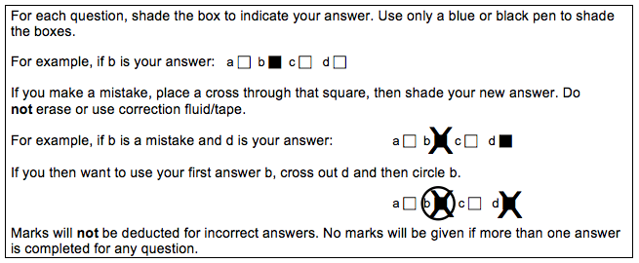

|  |  |
| --- | --- |
| **11** | a ⬜ b ⬜ c ⬜ d ⬜ |
| **12** | a ⬜ b ⬜ c ⬜ d ⬜ |
|  | a ⬜ b ⬜ c ⬜ d ⬜ |
|  | a ⬜ b ⬜ c ⬜ d ⬜ |
|  | a ⬜ b ⬜ c ⬜ d ⬜ |

|  |  |
| --- | --- |
| **6** | a ⬜ b ⬜ c ⬜ d ⬜ |
| **7** | a ⬜ b ⬜ c ⬜ d ⬜ |
| **8** | a ⬜ b ⬜ c ⬜ d ⬜ |
| **9** | a ⬜ b ⬜ c ⬜ d ⬜ |
| **10** | a ⬜ b ⬜ c ⬜ d ⬜ |

|  |  |
| --- | --- |
| **1** | a ⬜ b ⬜ c ⬜ d ⬜ |
| **2** | a ⬜ b ⬜ c ⬜ d ⬜ |
| **3** | a ⬜ b ⬜ c ⬜ d ⬜ |
| **4** | a ⬜ b ⬜ c ⬜ d ⬜ |
| **5** | a ⬜ b ⬜ c ⬜ d ⬜ |

**Section B: Short Answer (33 Marks)**

Answer all questions in the spaces provided.

**Question 13 (4 marks)**

Part (a) of the question refers to the diagram of a primate phylogeny below.

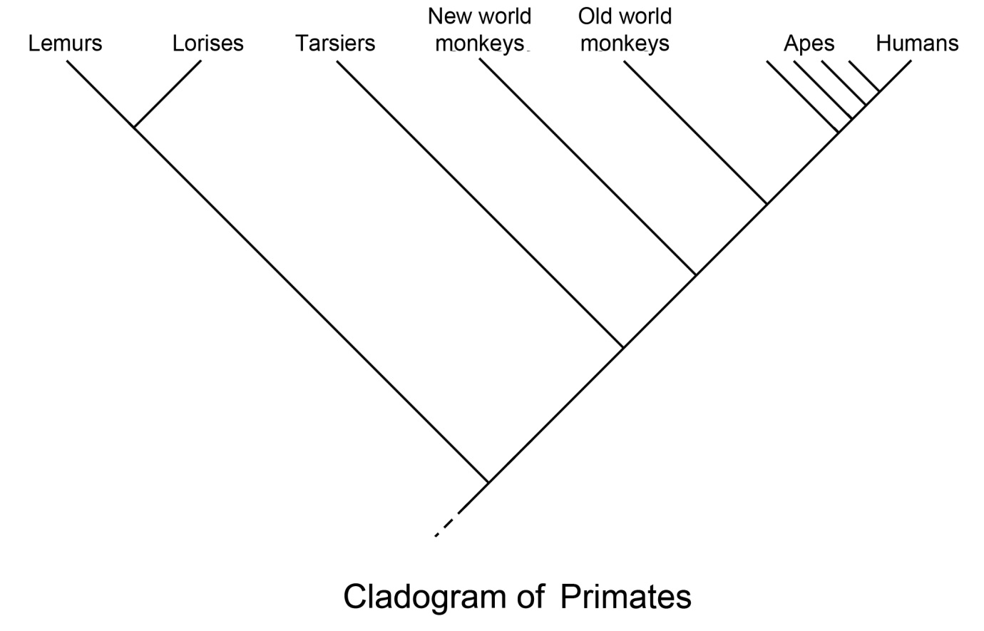

1. According to the phylogeny, which group of primates was the first to diverge in evolutionary time? (1 mark)

___________________________________________________________________

1. Complete the table below, describing the evolutionary trends that occur within Hominids. (3 marks)

|  |  |
| --- | --- |
| **Characteristic** | **Evolutionary trend** |
| Mobility of digits of the hand |  |
| Dental arcade |  |
| Diastema |  |

**Question 14 (7 marks)**

Part (a) & (b) of the question refers to the diagram of the Hominid specimenskull below.

1. Name the Hominid specimen below. (1 mark)

**___________________________________________________________________**

1. For each of the parts identified in the diagram of the skull, describe how the skull of *Homo habilis* differs from that shown in the diagram and give **one** advantage for *Homo habilis* for each change. (6 marks)

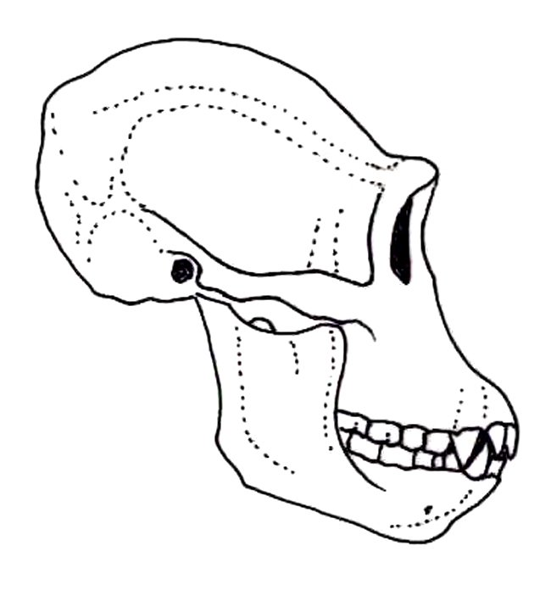

**Z**

**X**

**Y**

|  |  |  |
| --- | --- | --- |
|  | **How the skull of a typical modern *Homo habilis* differs to the diagram** | **Advantage** |
| **X** |  |  |
| **Y** |  |  |
| **Z** |  |  |

**Question 15 (6 Marks)**

Part (a) of the question refers to the tool diagrams A, B, C and D shown below.

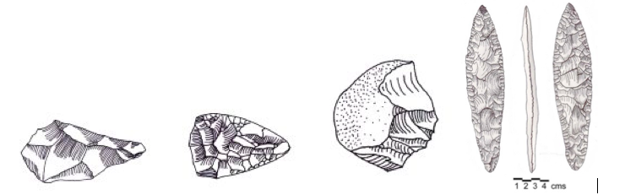 **A B C D**

1. Complete the table below by placing the tools A, B, C and D in the correct evolutionary sequence. Include the species it is associated with.

(5 marks)

|  |  |  |
| --- | --- | --- |
|  | **Letter – A, B, C or D** | **Used by** |
| **Oldest**  **Youngest** |  |  |
|  |  |
|  |  |
|  |  |

1. Tool culture has distinctly changed over time. Describe **one** trend relating to manufacture. (1 mark)

___________________________________________________________________

___________________________________________________________________

___________________________________________________________________

**Question 16 (4 marks)**

The table below give information on cranial capacity, height and mass of our early human ancestors up to modern day humans. (*All data is approximate*)

|  |  |  |  |
| --- | --- | --- | --- |
| **Species** | **Cranial capacity (cm3)** | **Height (m)** | **Mass (kg)** |
| *Australopithicus afarensis* | 430 | 1.2 | 30 |
| *Australopithicus africanus* | 460 | 1.3 | 35 |
| *Paranthropus robustus* | 540 | 1.5 | 65 |
| *Homo habilis* | 600 | 1.3 | 45 |
| *Homo erectus* | 1050 | 1.7 | 60 |
| *Homo neanderthalensis* | 1485 | 1.6 | 70 |
| *Homo sapiens* | 1350 | 1.9 | 75 |

(a) What conclusion can be drawn from the data given on cranial capacity? (2 marks)

___________________________________________________________________

___________________________________________________________________

___________________________________________________________________

(b) Using only the height and mass data of *Homo neanderthalensis* and *Homo sapiens,* give a possible explanation for this difference in build. (2 marks)

___________________________________________________________________

___________________________________________________________________

___________________________________________________________________

**Question 17 (13 marks)**

Archaeologists are studying evidence collected from a fossil dig. They believe the fossil remains belong to *Homo neanderthalensis* and have dated the age of the site at approximately 100, 000 years. The archaeologists are searching for more evidence to support their theory.

1. Identify **two** pieces of evidence, **not** including the skeletal remains, that archaeologists might find at the site. For each, propose the cultural behaviour associated with *Homo neanderthalensis* that the evidence suggests.

(4 marks)

|  |  |
| --- | --- |
| **Archaeological evidence** | **Cultural behaviour** |
|  |  |
|  |  |

1. Suggest **two** possible explanations for the extinction of *Homo neanderthalensis*.

(2 marks)

___________________________________________________________________

___________________________________________________________________

___________________________________________________________________

___________________________________________________________________

1. Explain **three** possible reasons why humans changed from a hunter-gatherer lifestyle to an agricultural one. (3 marks)

___________________________________________________________________

___________________________________________________________________

___________________________________________________________________

___________________________________________________________________

___________________________________________________________________

A footprint was found at an alternative site and on the basis of tools also found there, the archaeologists concluded the footprint belonged to early *Homo sapiens*.

1. Identify **two** types of tools that could provide support for the fossilised footprint to belong to Homo sapiens. For each type identify one feature of these tools.

(4 marks)

|  |  |
| --- | --- |
| **Tool Type** | **One feature of this type of tool** |
|  |  |
|  |  |

**End of Section B**

**Section C: Extended Answer (12 Marks)**

Answer the question below in the space provided

**Question 18**

When first discovered, scientists believed that the Australopithecines were bipedal and walked with a striding gait.

a) Explain **two** selection pressures (advantages) that may have led to the development of bipedalism in early hominids. (4 marks)

b) Describe **four** pieces of fossil evidence from the knee upwards that supports this belief and for each, explain the advantage to bipedalism that it provides. (8 marks)

___________________________________________________________________

___________________________________________________________________

___________________________________________________________________

___________________________________________________________________

___________________________________________________________________

___________________________________________________________________

___________________________________________________________________

___________________________________________________________________

______________________________________________________________________________________________________________________________________

___________________________________________________________________

___________________________________________________________________

___________________________________________________________________

___________________________________________________________________

___________________________________________________________________

___________________________________________________________________

___________________________________________________________________

___________________________________________________________________

___________________________________________________________________

___________________________________________________________________

___________________________________________________________________

___________________________________________________________________

___________________________________________________________________

___________________________________________________________________

___________________________________________________________________

___________________________________________________________________

___________________________________________________________________

___________________________________________________________________

___________________________________________________________________

___________________________________________________________________

___________________________________________________________________

___________________________________________________________________

___________________________________________________________________

___________________________________________________________________

___________________________________________________________________

___________________________________________________________________

___________________________________________________________________

___________________________________________________________________

___________________________________________________________________

___________________________________________________________________

___________________________________________________________________

___________________________________________________________________

___________________________________________________________________

___________________________________________________________________

___________________________________________________________________

___________________________________________________________________

___________________________________________________________________

___________________________________________________________________

___________________________________________________________________

___________________________________________________________________

___________________________________________________________________

___________________________________________________________________

___________________________________________________________________

___________________________________________________________________

___________________________________________________________________

___________________________________________________________________

___________________________________________________________________

___________________________________________________________________

___________________________________________________________________

___________________________________________________________________

___________________________________________________________________

___________________________________________________________________

___________________________________________________________________

___________________________________________________________________

___________________________________________________________________

___________________________________________________________________

___________________________________________________________________

___________________________________________________________________

___________________________________________________________________

___________________________________________________________________

___________________________________________________________________

___________________________________________________________________

___________________________________________________________________

___________________________________________________________________

___________________________________________________________________

___________________________________________________________________

___________________________________________________________________

___________________________________________________________________

___________________________________________________________________

___________________________________________________________________

____________________________________________________________________________________________________________________________________________________________________________________________________________________________________________________________________________

___________________________________________________________________

___________________________________________________________________

____________________________________________________________________________________________________________________________________________________________________________________________________________________________________________________________________________

___________________________________________________________________